BRIEF PROFILE OF THE FACULTY
Department of Law

Name : DEO PRAKASH DUBEY
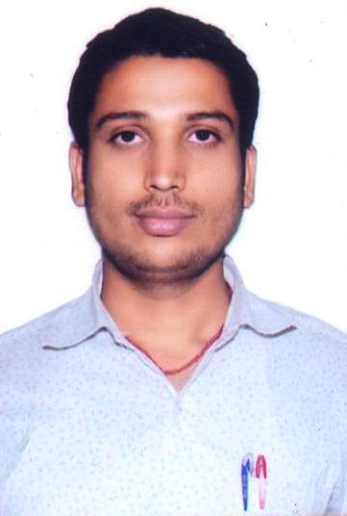

Designation : ASSISTANT PROFESSOR

Educational Qualification : LL.M.

Specialization in P.G. : Criminology

Email Address : advdpdubey@gmail.com

Contact : 9691942739

Achievements : 1. NET-2013& 2014 Qualified

Place: Durg DEO PRAKASH DUBEY

